PYTHON PROGRAMMING FILE

Name – Mukesh Dagar
Class-lll C
Roll no-24/SCA/BCA(AIML)/042

Q1. Write a Python program to calculate number of days between two dates.
Sample dates: (2014, 7, 2), (2014, 7, 11)
Expected output: 9 days
Understand (Basic operation) / L2
# Answer 1
from datetime import date

date1 = date(2014, 7, 2)
date2 = date(2014, 7, 11)

days = date2 - date1
print(days.days, "days")

Q2. Write a Python program that accepts an integer (n) and computes the value of n + nn + nnn.
Understand (Pattern recognition) / L2
# Answer 2
n = int(input("Enter an integer: "))

n1 = int("%d" % n)
n2 = int("%d%d" % (n, n))
n3 = int("%d%d%d" % (n, n, n))

print("Result:", n1 + n2 + n3)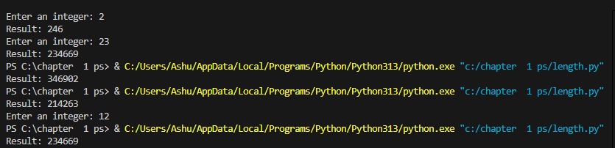

Q3. Ask the user for a number. Depending on whether the number is even or odd, print out an appropriate message.
Apply (Control structure & logic) / L3
# Answer 3
num = int(input("Enter a number: "))

if num % 2 == 0:
print("The number is even.")
else:
print("The number is odd.")
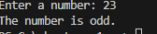

Q4. Write a Python program which accepts a sequence of comma-separated numbers and generate a list and a tuple.
Apply (Iterative algorithm) / L3
# Answer 4
values = input("Enter comma-separated numbers: ")

list_values = values.split(",")
tuple_values = tuple(list_values)

print("List:", list_values)
print("Tuple:", tuple_values)
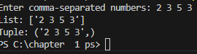

Q5. Write a Python program to calculate the sum of three given numbers. If the values are equal, return thrice of their sum.
Apply (Loop and formula use) / L3
# Answer 5
x = int(input("Enter first number: "))
y = int(input("Enter second number: "))
z = int(input("Enter third number: "))

sum = x + y + z

if x == y == z:
sum = sum * 3

print("Result:", sum)
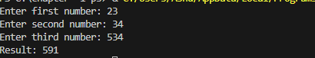

Q6. Write a Python program to test whether a passed letter is a vowel or not.
Apply (String manipulation) / L3
# Answer 6
ch = input("Enter a letter: ")

if ch in 'aeiouAEIOU':
print(ch, "is a vowel.")
else:
print(ch, "is not a vowel.")
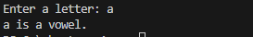

Q7. Take a list a = [1,1,2,3,5,8,13,21,34,55,89] and print all elements less than 5.
Extras:
Make a new list with these elements.
Ask user for a number and return elements smaller than that number.
Apply (Array manipulation) / L3
# Answer 7
a = [1, 1, 2, 3, 5, 8, 13, 21, 34, 55, 89]

print("Numbers less than 5:")
for i in a:
if i < 5:
print(i)

new_list = [i for i in a if i < 5]
print("New list:", new_list)

num = int(input("Enter a number: "))
user_list = [i for i in a if i < num]
print("Numbers smaller than", num, ":", user_list)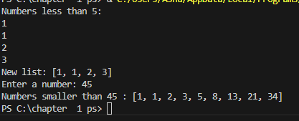

Q8. Create a program that asks the user for a number and prints all its divisors.
Apply (Modulo Logic) / L3
# Answer 8
num = int(input("Enter a number: "))

print("The divisors of", num, "are:")
for i in range(1, num + 1):
if num % i == 0:
print(i)
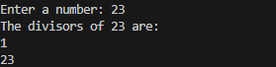

Q9. Take two lists and return a list containing only the common elements (without duplicates).
Apply (List Operations) / L3
# Answer 9
a = [1, 1, 2, 3, 5, 8, 13, 21, 34, 55, 89]
b = [1, 2, 3, 4, 5, 6, 7, 8, 9, 10, 11, 12, 13]

common = []

for i in a:
if i in b and i not in common:
common.append(i)

print("Common elements:", common)
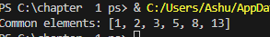

Q10. Ask the user for a string and print whether it is a palindrome or not.
Apply (Slicing) / L3
# Answer 10
text = input("Enter a string: ")

if text == text[::-1]:
print("It is a palindrome.")
else:
print("It is not a palindrome.")
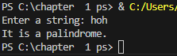

Q11. Let’s say I give you a list saved in a variable: a = [1, 4, 9, 16, 25, 36, 49, 64, 81, 100]. Write one line of Python that takes this list a and makes a new list that has only the even elements of this list in it.

# Answer 11
a = [1, 4, 9, 16, 25, 36, 49, 64, 81, 100]
new_list = [x for x in a if x % 2 == 0]
new_list
